# **Audio Bible for the Elderly Project**

www.dabible.com

We of “DaBible Foundation” we are a team of energetic youths burning for Christ with a vision of putting the word of God into the hearts of our generation through digital audio format. Over the last 5 years, we have successfully translated and transcribed the Bible into three African Languages. We have produced the first and only complete (old and new testament) audio bible in Yoruba, Pidgin and Hausa Language.

Presently, our Yoruba Audio Bible mobile app has been downloaded by 190,000 users, and our present data shows that the Yoruba Audio Bible is played more than 500,000 times in a day. All our mobile apps are rated 4.5 stars and we are getting loads of “Thank You” messages from our users

BUT …

## The Abandoned Generation

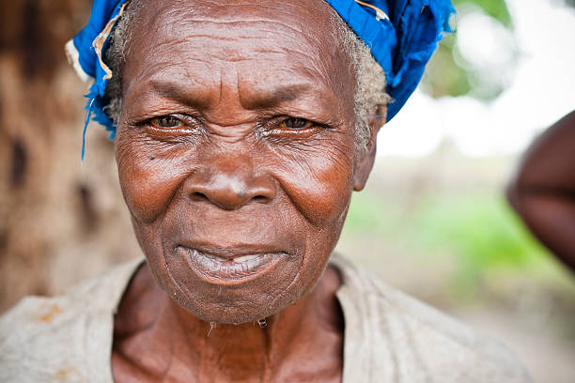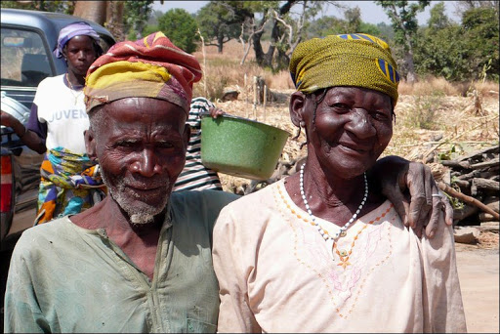

The Lord has laid a heavy burden on our hearts about our elderlies in the remote villages.

* Their children have relocated to the cities or studying on campuses,
* They cannot read and write; thus, they can’t read the bible.
* They cannot use a mobile app,
* Some of them are so old that they cannot walk to church meetings any longer.
* The only knowledge they have is idolatry background
* When they pray, they communicate with incantations and African proverbs (out of the abundance of the heart, the mouth speaketh)
* Finally, we call them witches because the devil has mastered the depravity of our mindset to these abandoned generations.
* Every day, one or two of these elderly dies in our generation.

## How God Called Us

This burden has been heavy on us for several years until it became very crystal clear like water. God sent many infallible witnesses of his burden for this abandoned generation, and recently, the Holy Spirit opened up two scriptures to us.

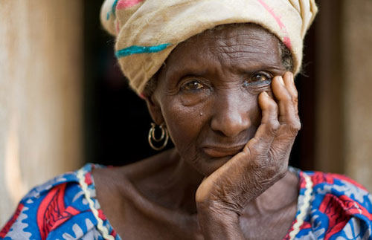

How then can they call on the One in whom they have not believed? And how can they believe in the One of whom they have not heard? And how can they hear without someone to preach? And how can they preach unless they are sent? As it is written: “How beautiful are the feet of those who bring good news!”

Romans 10:14-15

We are ready to be obedient to this call because a single soul means the world to the father…it costs him so much which includes sending his own beloved son.

## SOLAR POWERED Elderly Friendly Audio Bible Device

We have developed a device that we will be providing to our elderly people **FOR FREE.** Below are some sample image of the product and we already have a partnership agreement with our Chinese sister company to produce this amazing device. We hope to have these devices ready and available for our elderlies as soon as possible.

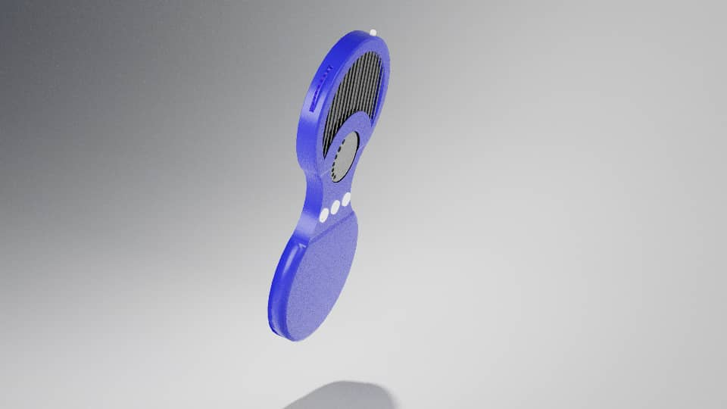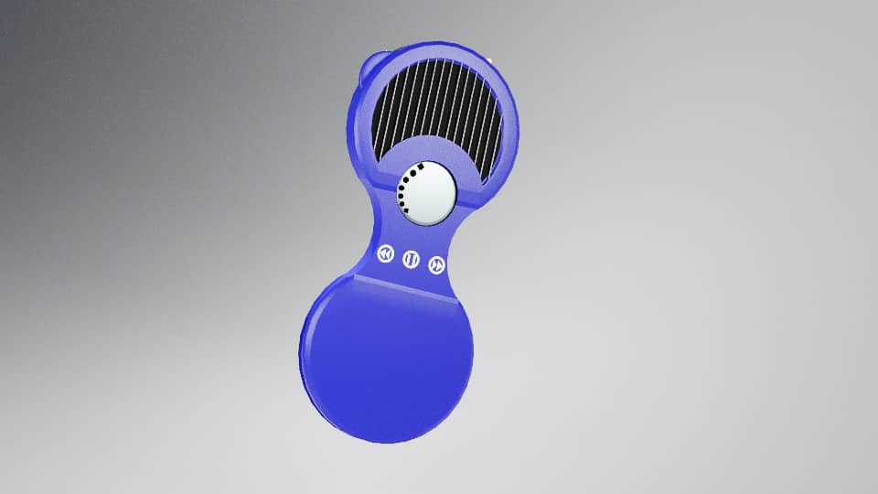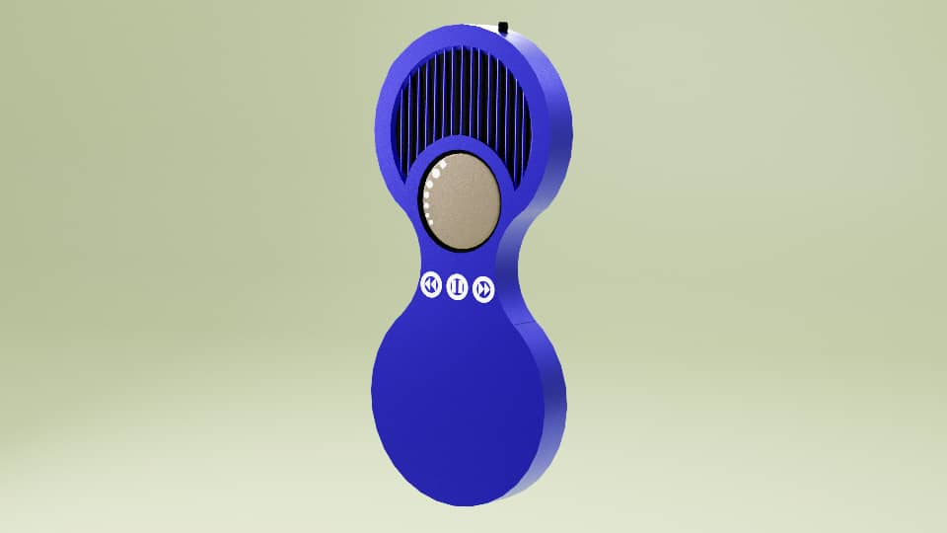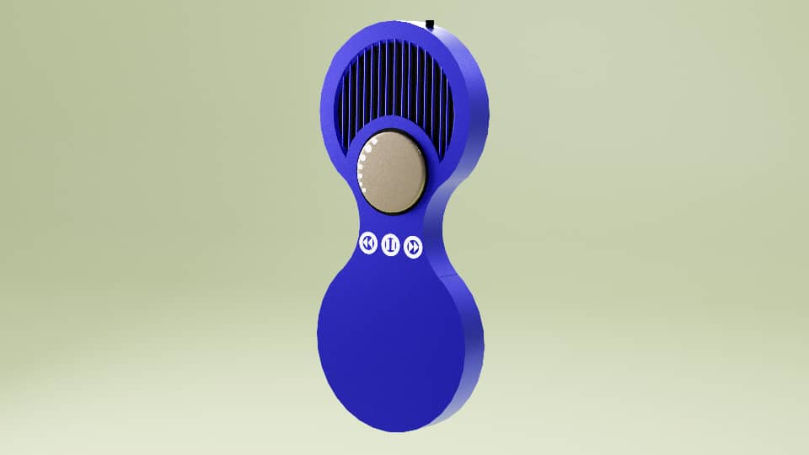

# Features of the Device

* Solar Powered
* AA Battery
* Old Testament
* New Testament
* Flash Light
* Easy to Use

# Our Plan

We want our old women and men, who are eighty years and above to be able to listen to the word of God in their own language.

Free Without Cost  
These devices cost an almost of $20 from our china company. We understand that our elderlies cannot afford this price, and they have no way of coming online to purchase it. Therefore, we are giving it to them for **FREE**.

# Remote Delivery Through Nigerian Christian Coppers Fellowship

We are sending our own network of campus coppers, and remote evangelism ministries to deliver our devices to them in the villages.

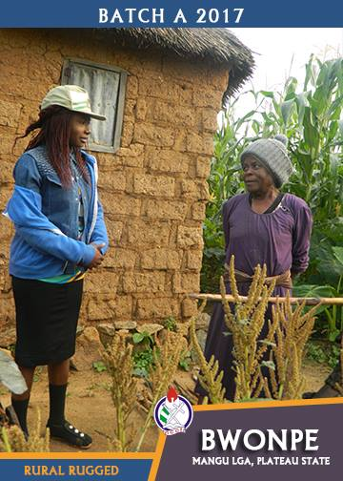 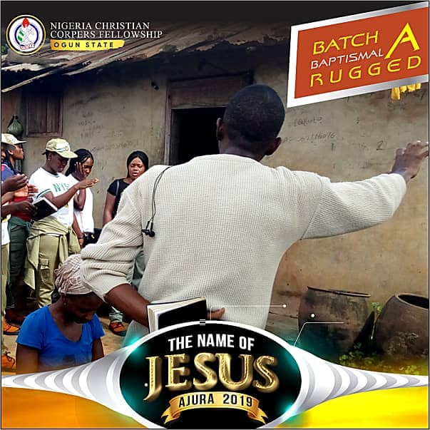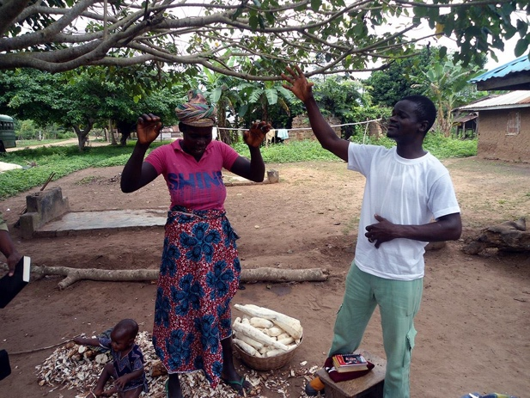 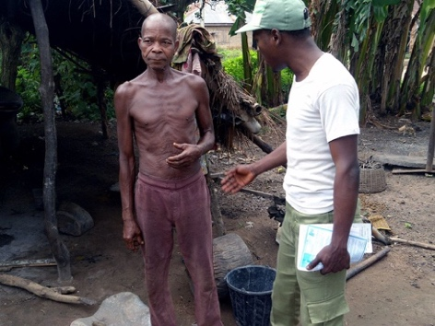 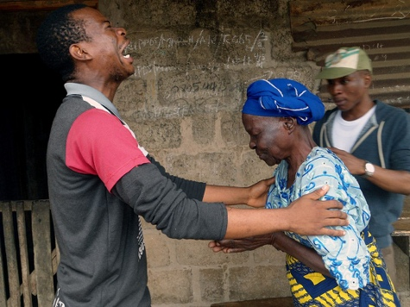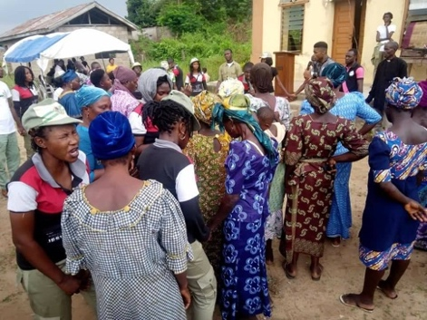

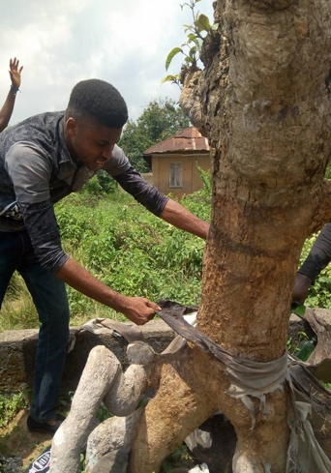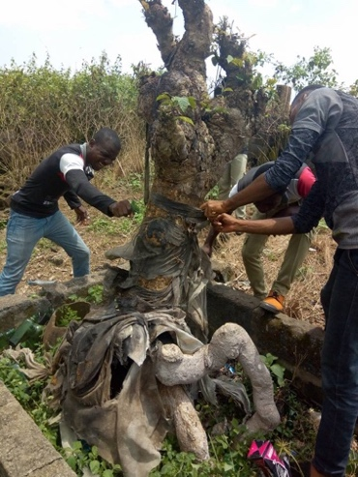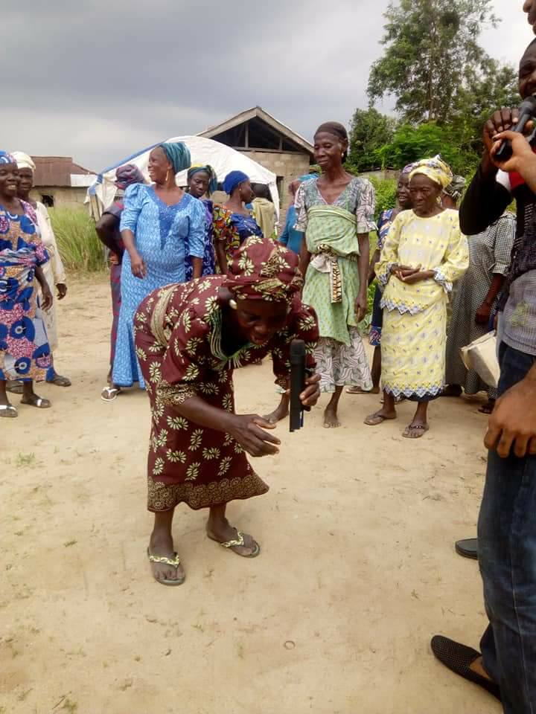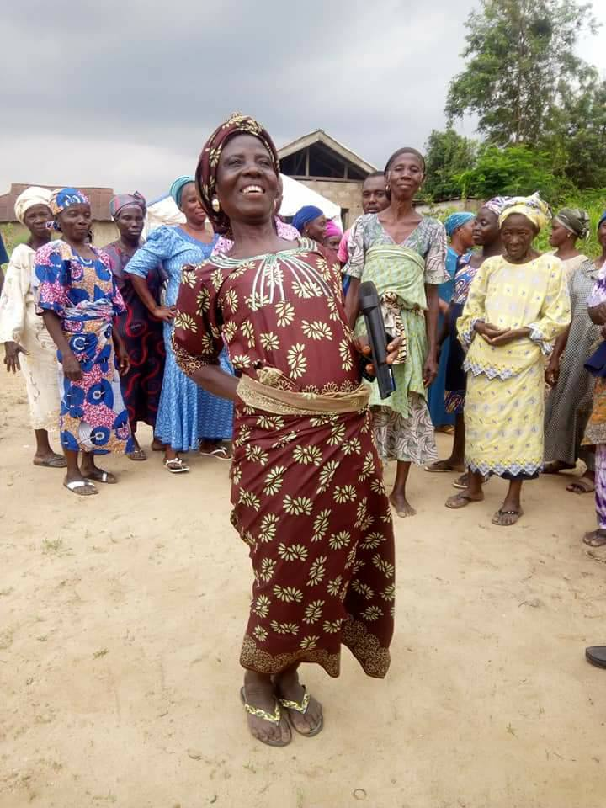

Picture Credits:   
NCCF National Secretariat: https://www.facebook.com/nccfnationalsecretariat/  
NCCF Ogun State Chapter https://www.facebook.com/nccfogunstate/photos

# Sponsor One Device for the Elderly

SPONSOR ONE DEVICE FOR THE ELDERLY

How can we provide this device for free when it costs money? We are launching a campaign called “Sponsor One Device for the Elderly”. If each one of us can donate $40 towards this course, we will be able to provide this device for free to our elderlies in remote villages.



# How to Donate

**CASHAPP:**  
DaBibleFoundation

**ZELLE:**   
+15093394854   
(Sanmi Ajanaku)

**GoFundMe:**   
Coming Soon

**WEBSITE:**

**www.dabible.com**

# Cost of Procurement

**Mold Cost:** **$6870**

**Minimum Bulk Order:** 2000 units

***\*\**** *Mold fee can be refunded if order above 20,000 units is placed within 2 years*

**Shipping:** *Will be calculated after Mold is built for correct unit weight.*

|  |  |  |  |
| --- | --- | --- | --- |
|  | Audio Bible **ONLY** | Audio Bible +  **Flash Light** | Audio Bible + **Flash Light + Radio** |
| Unit Cost | $11.50 | $12.50 | $12.50 |
| 2000 Units | 23,000 | 25,000 | 25,000 |
| 5000 Units | 57,500 | 62,500 | 62,500 |
| Est Shipping |  |  |  |

## Terms of Agreement with Shenzhen ALSO Shuyuan Technology Co., Ltd.

* DaBible Foundation must pay 50% of mold fee upfront. $3,435
* Sample mold will be shipped after production for testing and iteration. FREE
* Once test and approve final mold, we must pay remaining 50% $3,435
* We must pay 30% deposit for bulk order (min 2000 units) $7,500
* We must pay 70% balance before shipment. $17,500

*NOTE: Shenzhen ALSO can deliver in batches, but we must pay for the total amount of batch before they ship out, e.g we can pay for 1000units now, then rest 1000units after few weeks to ship them.*

# Manufacturer

**Contact:** Victoria

**Company Name:** Shenzhen ALSO Shuyuan Technology Co., Ltd.

**Country/Region:** China

**Address:** 4/F Ketujia Building No.55 Guanlan Street, Fucheng Xincheng Community LongHua Area,

**Telephone:** 0086-755-27626082, 27626085

**Mobile Phone:** 13662239462

**Fax:** 0086-755-27626085

**Operational Address:** Fanhai Tech Park, Guanlan, Shenzhen, Guangdong, China

**Website:** http://www.szalso.com

**Website on alibaba.:** ouang.en.alibaba.com

Estimated Shipping

Estimated Single package size: 58 x 38 x 35 cm

Estimated Single gross weight: 12.500 kg

# 501c NGO Registration

We are presently working on our 501C company registration as DaBible Foundation in the United States of America. Presently, we are registered in Nigeria but approved under the name Kerygma Foundation as opposed to our desired name by the Nigerian Cooperate Affairs Commission.

We are still contemplating on getting a DBA (Doing Business As) Kerygma Foundation RC-14007 or submit for another round of registration for our name DaBible Foundation both in Nigeria and the United States.

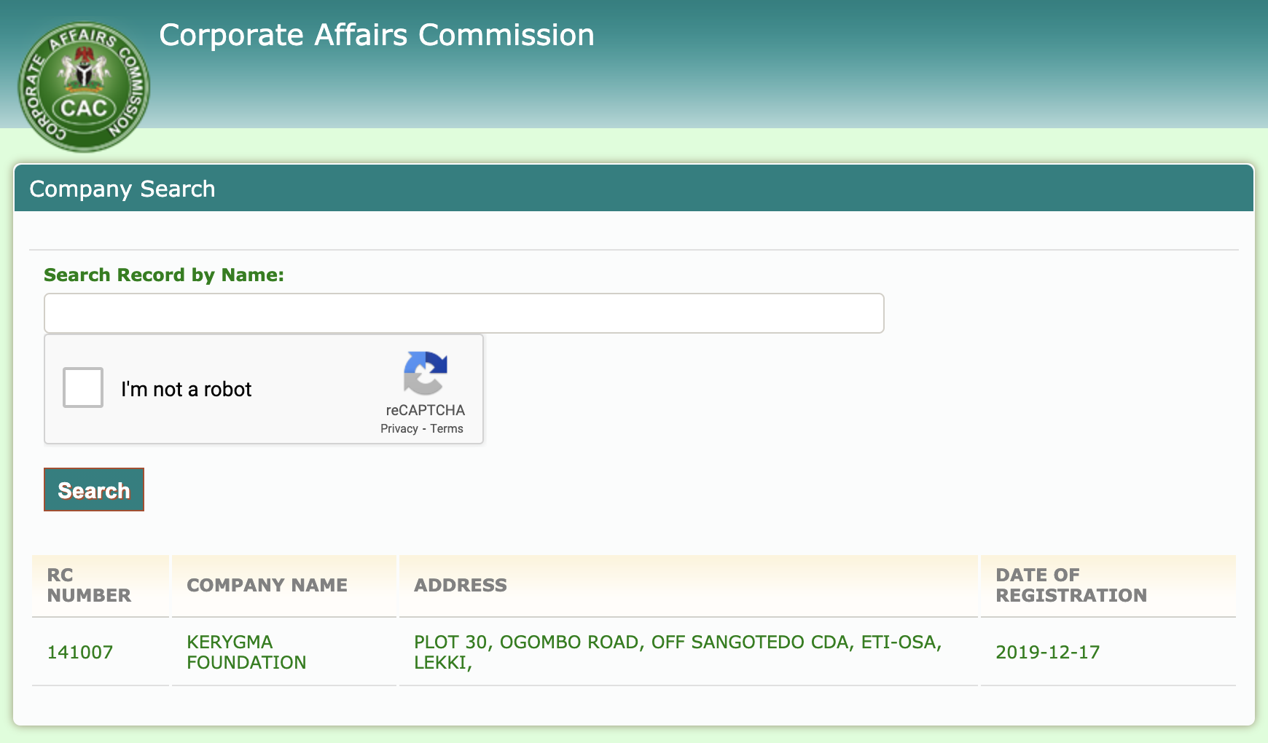

Thanks.

A message from one of our leaders, Sanmi Ayotunde.

“*I remember as student in Junior High School, we had some people deliver many Gideon bible to my school for free. I was not present at the assembly when they were giving away the bibles to the students. I came late to school on that day. When I arrived, an older student—who was like an older brother to me—informed me that they were giving free bibles and insisted I get a bible. I ran off quickly to get mine and I managed to get one of the copies they left behind. I read that Gideon bible seriously then. While I did not receive salvation then, that incident changed my life. The older student that told me to go get a bible then was deaf and dumb. He actually didn’t even hear what was said at the assembly. He only knew that the bible was important for my life, and I had to get a copy. He did everything he could to communicate this to me. And for me that day getting that bible was a must. I saw just how much effort my brother put to tell me about them. I was touched by this that I decided to read this bible seriously.*

*Now, when I remember this incident, I am still amazed. Surprisingly, my deaf and dumb brother was the one that led me to read my very first bible. Wow! No wonder the bible says, ‘how beautiful are the feet of those who bring good news!’. Some people somewhere paid for those bibles that were shared at the school that day. Some people chose to bring those bibles to our school that day. And my older brother who is deaf and dumb chose to pass this news to me. I got the bible free of charge, but countless people contributed to me getting this bible. Now, we have the opportunity to do the same. We need funds for making this audio devices. We need people to go into remote villages and distribute these devices to the elderlies. Will you be the ones to help proclaim the gospel?”*

There you have it. We have to raise funds to support this project. These devices are going to be produced so we need committed people that will continue to support the production of this this device. We also need to find a proper distribution channel. People that will go on to distribute these devices in remote villages. This is the burden placed in our hearts and we pray for its fulfilment in Jesus name.